[Click here and type Paper Title]
Sub theme:
Paper Code No. (e.g. A-10 or B-12 etc.)
[Click here and type Paper Author(s)]¹
¹[Click here and type Author(s) Affliations]

Abstract
Click
Keywords
Type your keywords here, separated by semicolons; [the keywords are formatted as Keywords]

1. Introduction
It is expected that authors will submit carefully written and proofread material. Careful checking for spelling and grammatical errors should be performed. Papers should clearly describe the background of the subject, the authors’ contribution, including the methods used, results and concluding discussion on the importance of the work from both scholarly and managerial perspectives. [Paragraph]
The Full Paper must be written in English within 10 pt Times New Roman. The text should be justified. The Full Paper including figures, tables and references must have a word limit of 2500 to 3000 words or a minimum length of 6 pages and cannot exceed 15 pages. The section headings should be arranged by numbers, bold and 12 pt as illustrated below.
1.1 Structure
Files must be in MS Word only and should be formatted for direct printing. Figures and tables should be embedded and not supplied separately.
Follow this order when typing manuscripts: Title, Authors, Affiliations, Abstract, Keywords, Main text -Introduction, Literature review, Materials and Methods, Results and Discussion, Conclusion (including figures and tables), Acknowledgements, References, and Appendix. Collate acknowledgements in a separate section at the end of the article, and do not include them on the title page, as a footnote to the title or otherwise.
Bulleted lists may be included and should look like this:
- First point
- Second point
- Third Point
- Fourth Point
- And so on
Please do not alter the formatting and style layouts that have been set up in this template document. As indicated in the template, papers should be prepared in single-column format suitable for direct printing onto paper with a trim size of 165 x 262 mm. Do not number pages on the front, as page numbers will be added separately for the preprints and the Proceedings. Leave a line clear between paragraphs
1.2 Tables
All tables should be numbered with Arabic numerals. Every table should have a caption. Headings should be placed above tables, left justified. Only horizontal lines should be used within a table, to distinguish the column headings from the body of the table, and immediately above and below the table. Tables must be embedded into the text and not supplied separately. Below is an example which the authors may find useful.
Table 1: Table layout. Captions for Tables are placed above. [Table title]
An example of a column heading | Column A (t) | Column B (t)
And an entry | 1 | 2
And another entry | 3 | 4
And another entry | 5 | 6
And another entry | 7 | 8
Reference:
1.3 Construction
Minimum 8 no. of references to be listed. References must be listed at the end of the paper. Do not begin them on a new page unless this is absolutely necessary because of spacing issues. Authors should ensure that every reference cited in the text appears in the list of references and that every reference included in the reference page is to be included in-text as well.
Indicate references in the text by referring to the APA style’s in-text citation; the author-date method. This means that the author’s last name should be followed by the year of publication and a complete reference of it should appear in the reference list at the end of the paper. An example of in-text should be as follows: (Matthews, 1992).
Some examples of how your references should be listed are given at the end of this template in the ‘References’ section, which will allow you to assemble your reference list according to the correct format and font size.
1.4 Section
Section headings should be left justified, bold, with the first letter capitalized and numbered consecutively, starting with the Introduction. Sub-section headings should be in capital and lower-case italic letters, numbered 1.1, 1.2, etc, and left justified, with second and subsequent lines indented. All headings should have a minimum of two text lines after them before a page or column break. Ensure the text area is not blank except for the last page.
1.5 General
Avoid hyphenation at the end of a line. Symbols denoting vectors and matrices should be indicated in bold type. Scalar variable names should normally be expressed using italics. Weights and measures should be expressed in SI units. All non-standard abbreviations or symbols must be defined when first mentioned, or a glossary provided.
1.6 File
Please title your files in this order ‘INCoRBE24_Papercode’.

2. Illustrations
The number of illustrations (including figures and tables) to be limited to a maximum of 8 nos. All figures should be numbered as illustrated (1,2,3,..….). Number figures consecutively in the order in which reference is made to them in the text, making no distinction between diagrams and photographs. Every figure should have a caption. All photographs, schemas, graphs and diagrams are to be referred to as figures. Line drawings should be good quality scans or true electronic output. Low-quality scans are not acceptable. Figures must be embedded into the text and not supplied separately. The preferred formats of figures are PNG, JPEG, etc. Lettering and symbols should be clearly defined either in the caption or in a legend provided as part of the figure. Please ensure that all the figures are of 300 DPI resolutions, as this will facilitate good output.
Figure number and caption should be typed above the illustration and reference at the bottom in 10 pt, italic and left justified. Leave about one line of space between the actual text and figure (including caption). Never place any text next to a figure. Leave this space blank. The most convenient place for placing figures is at the top or bottom of the page. Avoid placing text between figures as readers might not notice the text.
For example, see Figure. 1.
Figure1: Captions for images are placed above. [Figure title]
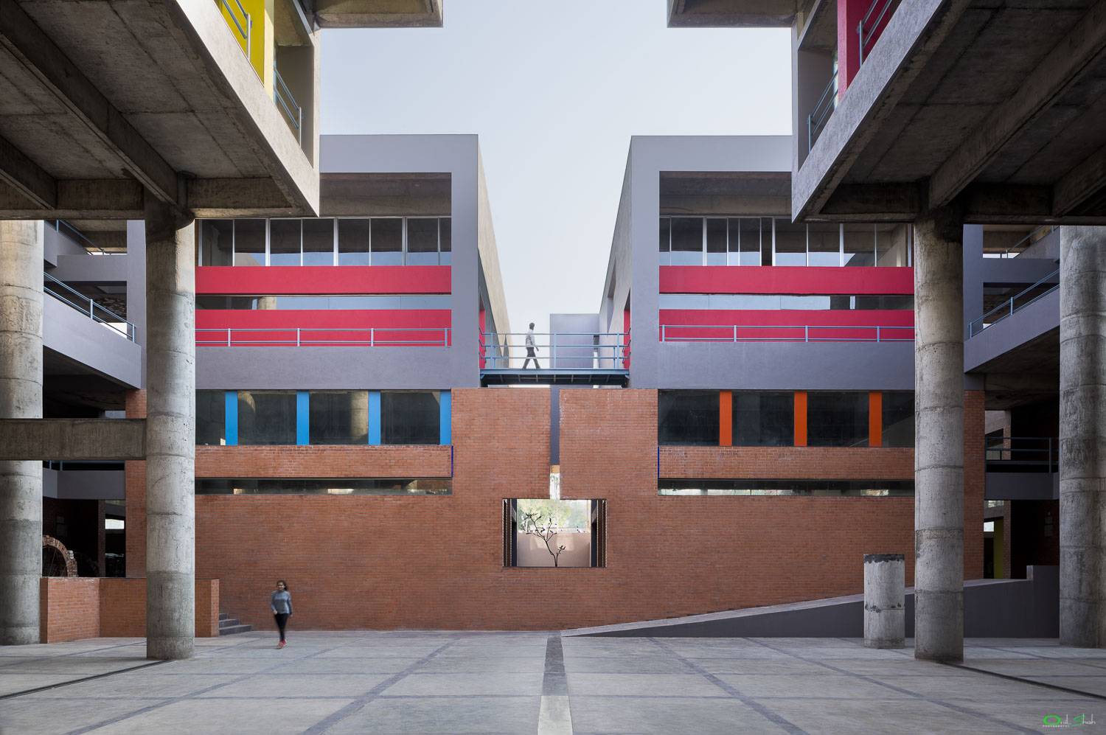
Reference:
2.1 Footnotes
Footnotes should be avoided if possible. Necessary footnotes should be denoted in the text by consecutive superscript letters1. The footnotes should be typed single spaced, and in smaller type size (8 pt), at the foot of the page in which they are mentioned, and separated from the main text by a one line space extending at the foot of the column. The ARCHIVE-footnote style is available in the MS Word for the text of the footnote.
Please do not change the margins of the template as this can result in the footnote falling outside printing range.
3. Conclusions
Conclusions should state concisely the most important propositions of the paper as well as the author’s views of the practical implications of the results.
Acknowledgements
Acknowledgements and Reference heading should be left justified, bold, with the first letter capitalized but have no numbers. Text below continues as normal.

References[References to be listed one below other in alphabetical order with numbering in 9 pt. Times New Roman. Following are the examples for writing references, text in red to be omitted]
[For an article in a journal]
- Goss, R. O., 1990, Economic policies and seaports: strategies for port authorities. Maritime Policy and Management, 17(4), 273-287.
[Book]
- Frankel, E. G., 1987, The World Shipping Industry (London, U.K.: Croom Helm).
[Chapter in a book]
- Friesz, T. L., 1981, The multi objective optimization in transportation: the case of equilibrium network design. In: Organizations: Multiple Agents with Multiple Criteria, edited by J. N. Morse. Lecture Notes in Economics and Mathematical Systems, Vol. 190 (New York: Springer-Verlag), pp. 116-127.
[Report, proceedings, and unpublished literature (a)]
- Tan, H., Gershwin, S., and Athans, M., 1979, Hybrid optimization in urban traffic networks. MIT Report Dot-TSC-RSPA-79-7.
[Report, proceedings, and unpublished literature (b)]
- Asakura, Y., and Sasaki, T., 1990. Formulation and feasibility test of optimal road network design model with endogenously determined travel demand. Proceedings of the 5th World Conference on Transport Research, Yokohama, Japan, July, pp. 351-365
[Report, proceedings, and unpublished literature (c)]
- Yang, H., Bell, M. G. H., and Meng, Q., 1997, Equilibrium zone reserve capacity under network capacity constraints. Working paper, The Hong Kong University of Science and Technology.
[Newspaper or magazine]
- Smith, A., 1996, Labour ditches plans to re-regulate buses. Financial Times, 30 December.
[Internet source (with title, date of access and the universal resource locator in full)]
- UNO, Charter of the United Nations (Preamble), Date of access: 21/11/2012. http://www.un.org/en/documents/charter/preamble.shtml.
[Government legislation (a)]
- US CONGRESS, Senate Committee on Foreign Relations, 1956, The Mutual Security Act of 1956, 84th Congress, second session, report 2273.
[Government legislation (b)]
- UNITED KINGDOM PARLIAMENT, Committee on the Working of the Monetary System [Radcliffe Committee] 1960, Principal Memoranda of Evidence, vol. 2, Cmd 1958.
[Government legislation (c)]
- UNITED NATIONS GENERAL ASSEMBLY, Secretariat for Economic Affairs, 1951, Methods of Financing Economic Development in Less Developed Countries, report II B2.

1 Footnote

